Initial Charts and Graphs

Figure 1 — Concurrency vs. latency
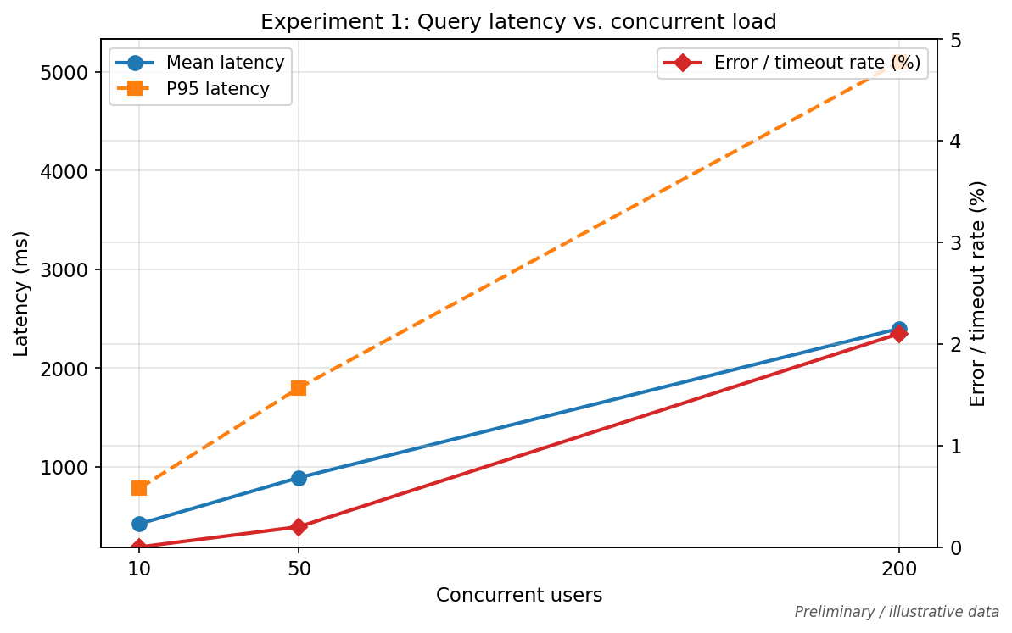
Shows how mean and P95 query latency change as concurrent users increase (e.g., 10 → 50 → 200). The right axis shows error or timeout rate, which helps spot overload when the system starts failing under load.

Figure 2 — Index size vs. latency
Shows retrieval time and end-to-end latency as the number of indexed document chunks grows (e.g., 1k → 10k → 100k). The right axis shows approximate index memory, linking search cost and resource use to corpus size.

Figure 3 — Horizontal scaling
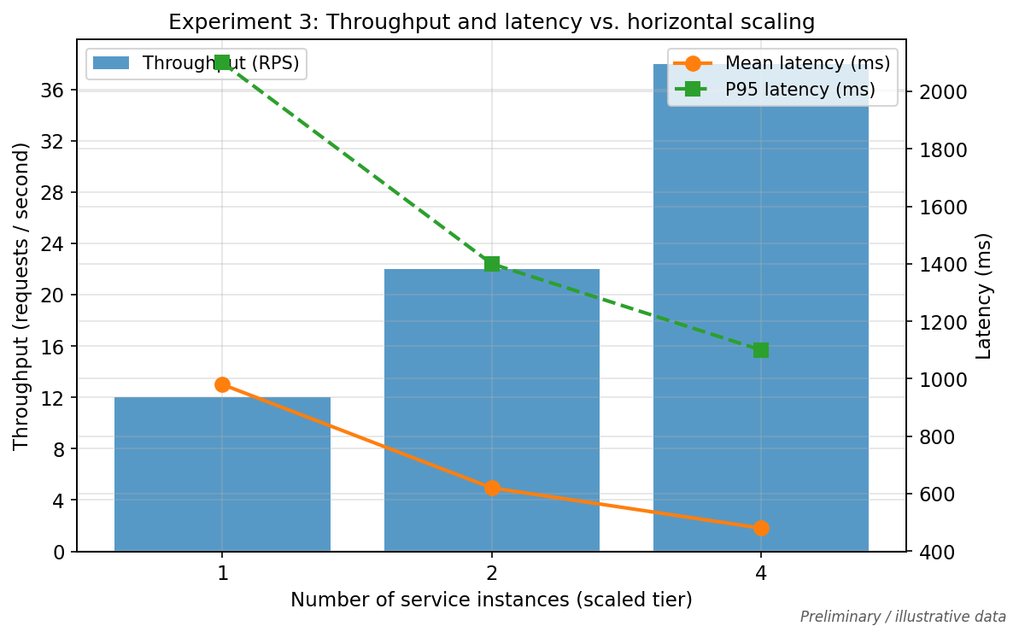
Compares throughput (requests per second) and mean/P95 latency when the scaled service runs with 1, 2, and 4 instances. It illustrates whether adding replicas improves capacity and how latency responds.

Figure 4 — Latency breakdown
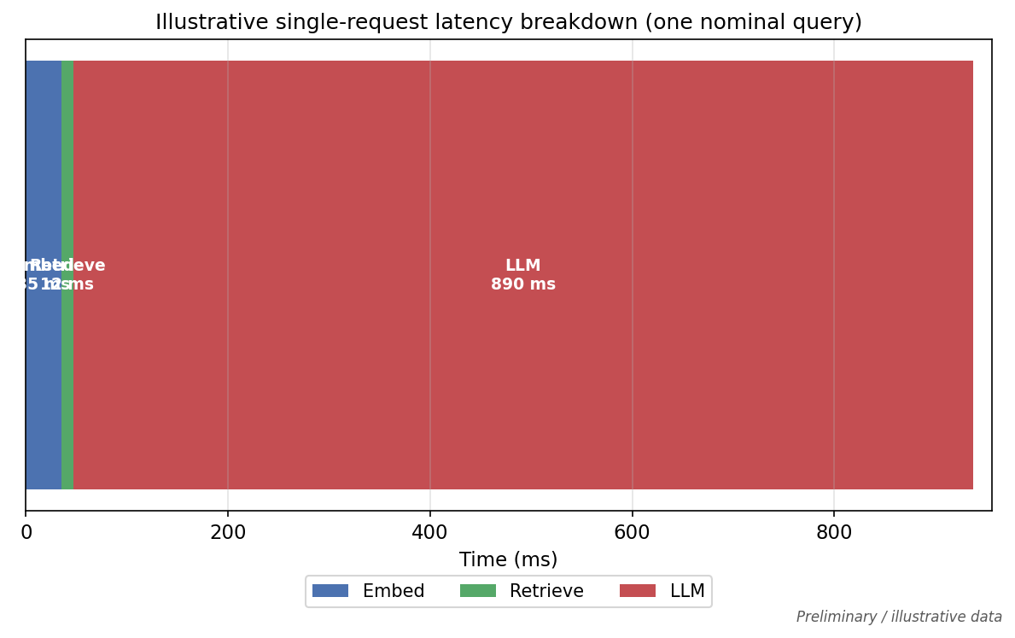
Illustrates how a single typical query splits time across embedding, vector retrieval, and LLM generation. It highlights which stage likely dominates total latency in a RAG pipeline.

